**H1B Visa Application Analysis**

-Biran Li

**Abstract**

This project aims to examine the H1B application data to help graduate students to increase their chances to get a job that can process the H1B visa application, while the data sources come from government websites during the past two years. According to this scenario, this data size is approximately 300MB. For processing, I would use “create table” Hive command to create the Hive table for the related data sets previously; secondly, I would load the CSV data file into Hive table; and at last, I would use Hive command to calculate and query the data needed. I hope to figure out what are the factors that will increase the chances to get the H1B visa application. Based on the analysis above and statistics from Hive, I can provide some suggestions for graduate students who need H1B visa to work legally in the United States.

**I. Introduction**

Over a million international students are studying in the United States in the year of 2015. Many of them are trying to get a H1B visa to legally work in the United States. H1B is a non-immigrant visa for foreign workers. It allows U.S. employers to temporarily employ foreign workers in specialty occupations. However, the U.S. government only gives out limited numbers of H1B visas every year. There are nearly 250,000 foreign applicants but there are only 85,000 visas provided. To apply for H1B visa, the employers need to pay for the application fee and prepare the paper work. Each employer only has limited spots to apply for foreign employees. Our goal is to assist graduate students who need H1B visa to increase their chances to get a job that can file the H1B applications. [1]

**Popular majors**

In the year of 2015, among all the H1B applicants, 27% were majored in computer system analysis, 25% majored in computer programing, 22% majored in software developing, 12% majored in computer occupations. 88% of all the applicants are majored in computer and software related areas.

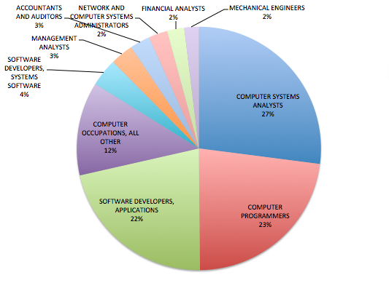

Figure 1.1

**2014 State Avg. Salary**

From figure 2.1, you can visualize clearly that the wages of states on the east coast are higher than other regions. Central states have lower wages than others. Among all the states, Virginia has the highest state average wage. [2]

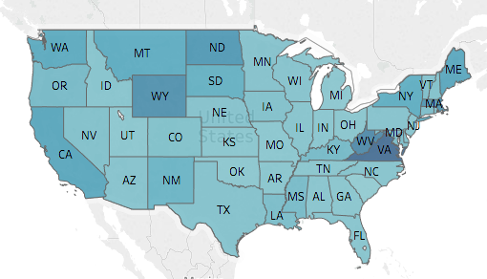

Figure 2.1

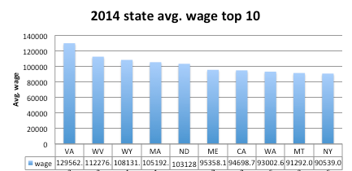

Figure 2.2

**II. Section**

**State H1B application**

From figure 3.1, 3.2 we can visualize that the amount of H1B applications in 2014 and 2015 are very similar. From Figure 3.3, California and Texas are the two states that filed the most H1B applications in both 2014 and 2015. Except these two states, many employers on the east filed more H1B applications than other regions. [3][4]

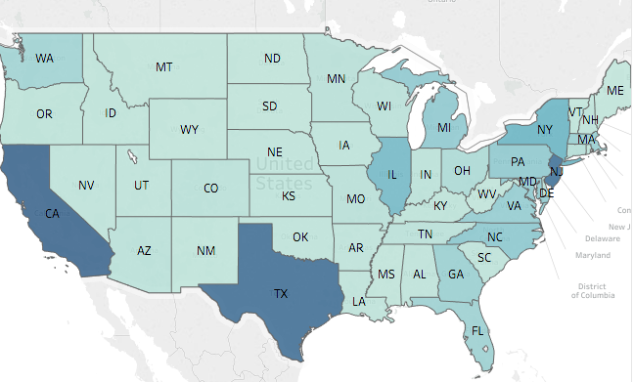Figure 3.1 2014 application numbers

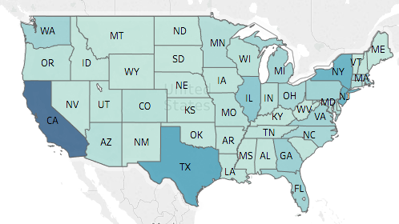Figure 3.2 2015 application numbers

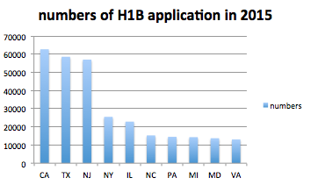

Figure 3.3

**2015 Top Employers**

Figure 4.1 shows the top 30 employers who filed the most H1B in 2015. Infosys Limited, Tata Consultancy Services Limited and IBM were the three companies that filed the most H1B applications in 2015. [3]

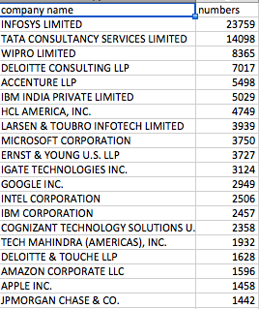

Figure 4.1

**III. Conclusion**

**A couple suggestions for graduate students:**

1. Apply jobs in Texas, California, and New York
2. Consider to select majors in computer related majors.
3. If suitable jobs are available, applyin the top 20 firms who filed the most H1B applications in the year of 2014 and 2015.
4. Companies located in the North and on the coasts offer higher salaries than other areas.

**IV. Reference:**

[1] "SEVP releases 2015 international student data, launches interactive mapping tool." *U.S. immigration and Customs Enforcement*. N.p., 25 Mar. 2015. Web.

[2] "International Students in the United States." *Project Atlas*. N.p., Web.

[3] "H1B_FY2015." *UNITED STATES DEPARTMENT OF LABOR* . N.p., 2015. Web.

[4] "H1B_FY2014." *UNITED STATES DEPARTMENT OF LABOR* . N.p., 2014. Web.